BluePrint Project plan

Purpose

* Develop a timeline and roadmap
* Understand the scope of the project
* a professional product that allows users to conduct a custom analysis of tweets gathered from Twitter through one of two manners: by searching for tweets via regular expressions, or by using a custom software development kit (SDK)
* sole service that BluePrint provides is the support of the server that collects and stores tweets for the user to then access.

Scope

* Create an application that analyzes tweets directly from twitter in real time and generate reports that allows the data to be digested
* three components: the general-purpose tweet analyzer, a sophisticated analyzer class, and a class for non-technical customers.
  + use simple methods to go through and pull out particular tweets according to keywords.
  + sophisticated analyzer class is capable of going through and analyzing tweets from anywhere in the Continental United States and from that producing a weather map of the country.
  + The last component that is for the non-technical customers will have the ability to read a file that contains regular expressions and apply the regular expressions to tweets producing a list of tweets that match those expressions.
* Wanted to create a terrorism analysis of tweets based on keywords

SWOT Analysis

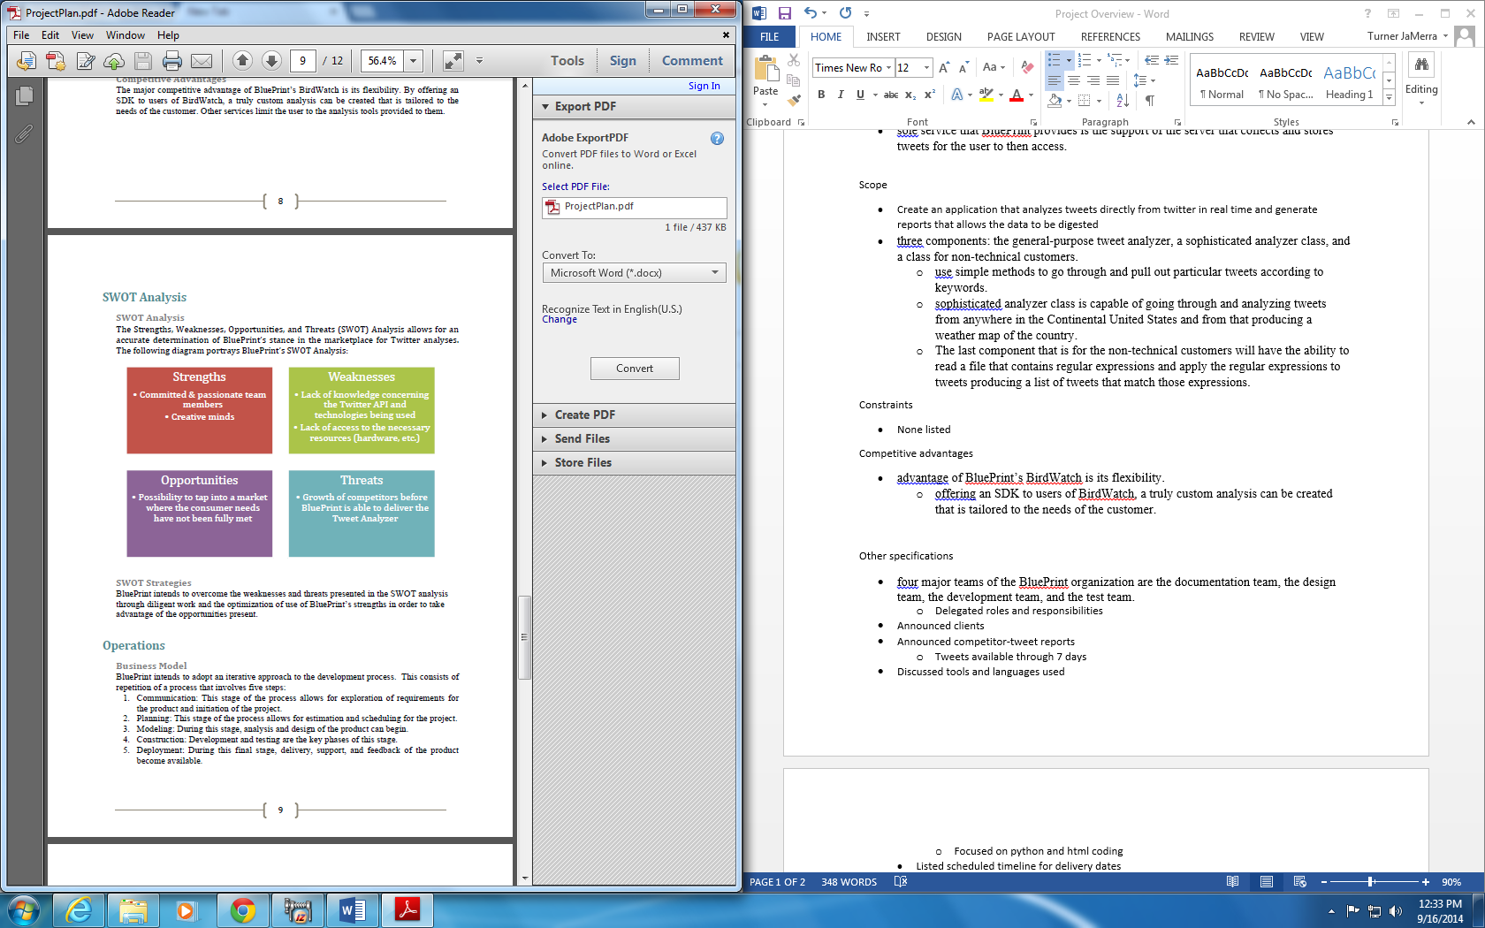

Competitive advantages

* advantage of BluePrint’s BirdWatch is its flexibility.
  + offering an SDK to users of BirdWatch, a truly custom analysis can be created that is tailored to the needs of the customer.

Other specifications

* four major teams of the BluePrint organization are the documentation team, the design team, the development team, and the test team.
  + Delegated roles and responsibilities
* Announced clients
* Announced competitor: tweet reports
  + Tweets available through 7 days
* Discussed tools and languages used
  + Focused on Java, IntelliJ IDEA, Java SE 7, JSON, Java FX scene builder, apache Cassandra, MS office
  + Estimated 250GB hard drive will be able to hold only enough tweet data for a couple of hours
* Listed scheduled timeline for project operations
  + MWF 1-2pm; TF 3:30-4:45 pm
* Development plan
* There are six major tasks to this project:
* Set up a server to collect and record all tweets
* Create an SDK for advanced users to utilize to make advanced analyses of tweets
* Create a simple user interface for users to allow for analysis display and tweet searches
* Develop a class to utilize regular expressions to analyze tweets
* Create a weather analysis of tweets with a graphical display
* Create a terrorism analysis of tweets based on keywords

Risk management

* Risk of having server shut down based on using a single server that collects and stores tweets
  + Disconnection of internet, loss of code, power outages
* If server shuts down blueprint intends to have server running as soon as possible after shutdown
* Extra copy of code stored on cloud service for quick recovery